**AIML**

**Domain:**

Promo Code Abuse Detection (Fraud Detection).

**Description:**

The Project focuses on identifying users who exploit Promotional Codes in online Payment gateways using statistical analysis and unsupervised learning to identify fraudulent user patterns.

**About Dataset:**

This dataset comprises of the information of the users registering for an online payment gateway app.

Unique ways to track the promo abusers using the following attribute information.

**Problem Statement:**

To predict whether a certain user is a promo abuser or not-

This can be achieved by two methods:

1) Creation of a Statistical Index by deriving signals from available attributes (columns) in the dataset to obtain a score on the authenticity of the user.

2) Signals derived can be multiple registrations by the same user, address derived from IP address and phone number not matching the address entered by the user, gibberish (fake) names used to make registrations.

2) Using unsupervised learning algorithms.

**Flowchart:**

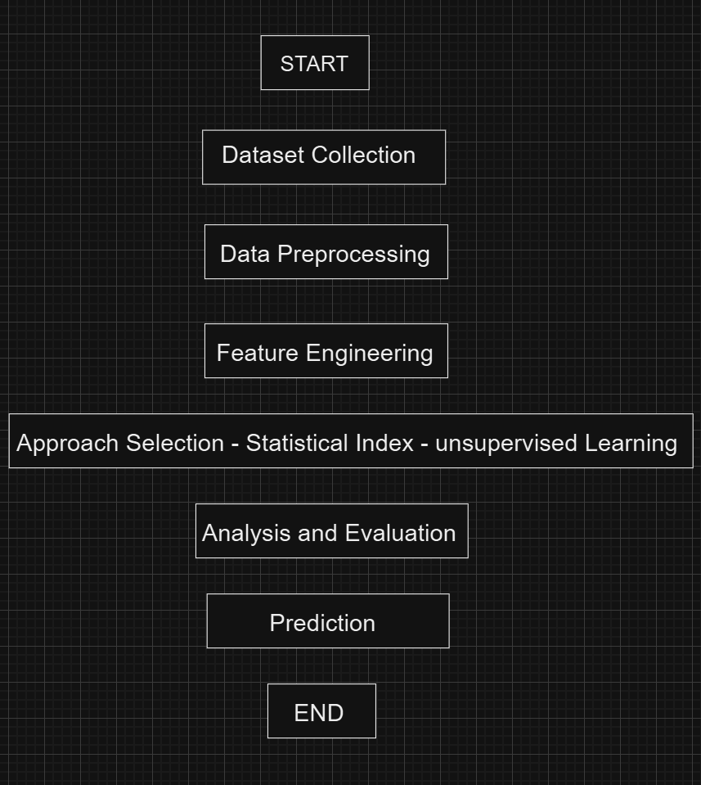

TEAM MEMBERS: -

2320030206: - M.M.S CHANDRA NAGU

2320030207: - A. SUBASH

2320030102: - G. NIKITHA CHOWDARY